**Top bar and footer requirements update:**

The guidelines that all websites should follow are below (note: this includes financial sites).

Requirements:

1. Add the **informa** top bar
2. Add footer
3. Ensure to check the legal entity referenced in the footer is correct.

**Top Bar:**

All teams should be following the web estate guidelines for the structure and format of the Top bar

The route to follow for all websites on the **top left of the bar** is as follows:

Informa Global Markets is part of the Financial Intelligence Division of Informa PLC

Link Financial Intelligence to: *financialintelligence.informa.com*

Top bar RAR file <https://www.dropbox.com/s/taryv9n1vtawjm9/top-bar-BI.rar?dl=0>

Top bar guidelines <https://www.dropbox.com/s/f5hv997v9dwmlqo/informa_top-bar-guidelines-16062015.pdf?dl=0>

**Please also replace the copy on the right of the Top Bar with the following:**

This site is operated by a business or businesses owned by Informa PLC and all copyright resides with them. Informa PLC’s registered office is 5 Howick Place, London SW1P 1WG. Registered in England and Wales. Number 8860726.

Circled below is where this copy needs to go:

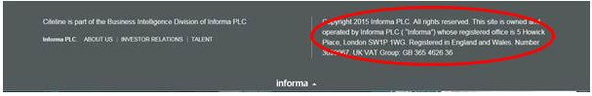

**Footer**

All of the footers vary on the sites, and there is going to need to be some individual consideration taken for each.

As a general rule there should be a link to the Financial vertical:

Financial -            financialintelligence.informa.com

**The legal entity in the footer:**

Please hyperlink Informa PLC to Informa.com:

IGM footer should include the following:

*Informa Global Markets is a trading division of* Informa Business Intelligence, Inc, a company registered in New York, USA with company number 043613351 whose registered office is 420 Lexington Avenue, Room 616-21, New York, NY 10170. Informa Business Intelligence Inc is part of Informa PLC (link to www.informa.com).

*Copyright ©* Informa Business Intelligence Inc.